1. A link to your application on Github

<https://ljpuetz1.github.io/n220spring2023/>   
2. A design section that describes how your program should operate, the actions needed to to achieve this operation, and the algorithm for what you believe would implement those actions.

What I need to do with this project

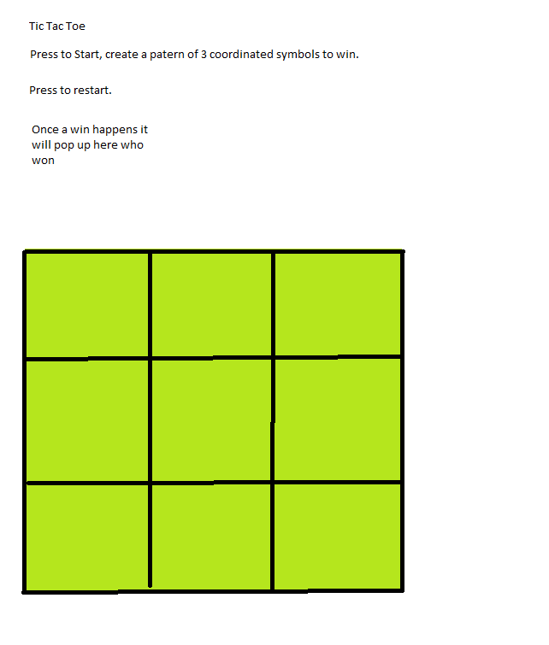  
3. A list of ALL RESOURCES (at least two) (websites, videos, notes, docs) you used to create your application. Rank these in order of utility, summarize what you used from each resource, how you thought about your project differently after finding and employing that resource. Write a sentence each about what you did, and did not, understand from the resource.

<https://www.scaler.com/topics/boolean-in-javascript/>

[CSS .class Selector (w3schools.com)](https://www.w3schools.com/cssref/sel_class.php)

[javascript - How to create a win condition for an if/else if/else statement for a memory game - Stack Overflow](https://stackoverflow.com/questions/48107186/how-to-create-a-win-condition-for-an-if-else-if-else-statement-for-a-memory-game)

[How to count clicks with javascript? - Stack Overflow](https://stackoverflow.com/questions/5862781/how-to-count-clicks-with-javascript)

4. Design notes that detail what you worked on for each session and one problem you overcame during the session.